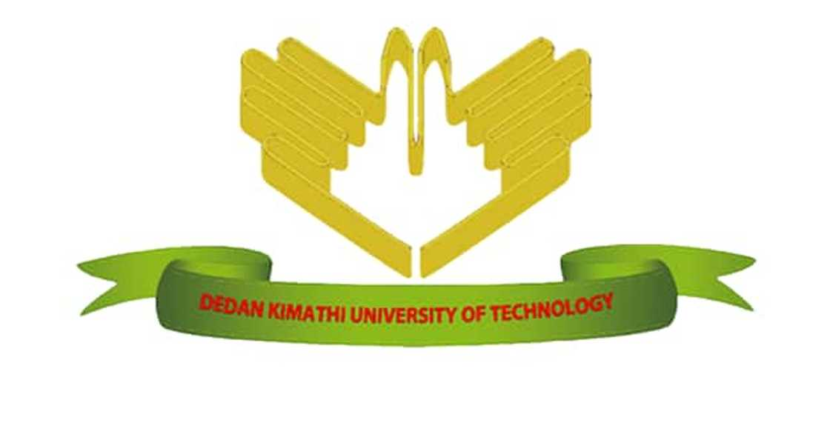
DEDAN KIMATHI UNIVERSITY OF TECHNOLOGY
SCHOOL OF COMPUTER SCIENCE AND INFORMATION TECHNOLOGY
BY
NAME: JAMES WAHITI
REGISTRATION NUMBER: C025-01-0832/2022
SUPERVISOR: DR. PATRICK GIKUNDA
CAPSTONE PROJECT: INNOVATION IN FIELD OF STUDY
PROJECT TITLE
A LOCAL AI-POWERED ACADEMIC SUPPORT SYSTEM USING LOCAL LARGE LANGUAGE MODELS

An abstract submitted in partial fulfillment of the requirements for the award of the degree of Bachelor of Science in Information Technology of Dedan Kimathi University of Technology

January 2026

Abstract
This presentation examines the design and development of a university-based Retrieval-Augmented Generation (RAG) chatbot implemented using locally deployed large language models to improve access to academic information within higher learning institutions. Many universities continue to rely on traditional information dissemination methods such as noticeboards, static documents, and manual communication through lecturers or administrative offices. These approaches often result in delayed responses, fragmented information sources, and increased dependency on human intermediaries, making it difficult for students to obtain timely and accurate academic information.
The proposed innovation integrates a document retrieval system with locally hosted language models to enable natural language interaction between users and institutional knowledge repositories. Academic resources—including course outlines, past examination papers, academic regulations, and policy documents—are processed and indexed to allow semantic search and context-aware response generation. By combining retrieval mechanisms with generative models, the chatbot minimizes hallucinations and ensures that responses are grounded in verified institutional documents.
Unlike cloud-based artificial intelligence systems, the locally deployed architecture enhances data privacy by ensuring that sensitive institutional information remains within university-controlled infrastructure. In addition, the system reduces reliance on continuous internet connectivity, lowers long-term operational costs, and provides improved reliability in low-bandwidth environments commonly experienced in many African institutions. The solution is designed to be scalable and adaptable, allowing deployment across multiple departments or institutions with minimal modification.
Overall, the innovation demonstrates how artificial intelligence can be tailored to address contextual challenges in African universities while promoting digital sovereignty, sustainable educational technology, and improved access to knowledge for students and academic staff.

Muhtasari
Uwasilishaji huu unachunguza usanifu na uundaji wa roboti ya mazungumzo ya chuo kikuu inayotumia mbinu ya Retrieval-Augmented Generation (RAG) kwa kutumia mifumo ya lugha mikubwa inayotekelezwa ndani ya miundombinu ya ndani ya taasisi. Vyuo vingi vya elimu ya juu bado hutegemea mbinu za jadi za usambazaji wa taarifa kama vile matangazo kwenye mabango, nyaraka tuli, na mawasiliano ya ana kwa ana kupitia wahadhiri au ofisi za utawala. Mbinu hizi mara nyingi husababisha ucheleweshaji wa taarifa, mgawanyiko wa vyanzo vya taarifa, na utegemezi mkubwa wa rasilimali watu, hali inayowafanya wanafunzi kushindwa kupata taarifa sahihi na kwa wakati unaofaa.
Ubunifu unaopendekezwa unaunganisha mfumo wa utafutaji wa nyaraka na mifumo ya kizazi cha lugha inayohifadhiwa ndani ya seva za chuo ili kuwezesha mwingiliano wa lugha ya kawaida kati ya watumiaji na hifadhi ya maarifa ya taasisi. Rasilimali za kitaaluma, ikiwemo mitaala ya masomo, karatasi za mitihani ya awali, kanuni za kitaaluma, na nyaraka za sera, huchakatwa na kupangwa ili kuruhusu utafutaji wa kimaana na utoaji wa majibu yanayozingatia muktadha. Kwa kuunganisha mbinu za utafutaji na kizazi cha maandishi, roboti hii hupunguza uwezekano wa kutoa taarifa zisizo sahihi na kuhakikisha kuwa majibu yanatokana na nyaraka rasmi za chuo.
Tofauti na mifumo ya akili bandia inayotegemea huduma za mtandaoni, usanifu wa ndani unaongeza usalama wa data kwa kuhakikisha kuwa taarifa nyeti za taasisi zinabaki ndani ya miundombinu inayodhibitiwa na chuo. Aidha, mfumo huu hupunguza utegemezi wa muunganisho wa mtandao wa kudumu, hupunguza gharama za muda mrefu za uendeshaji, na hutoa utendaji bora katika mazingira yenye changamoto za mtandao, hali inayojitokeza katika taasisi nyingi barani Afrika. Mfumo huu umeundwa kwa kuzingatia upanuzi na kubadilika, hivyo kuruhusu utekelezaji katika idara au vyuo vingine kwa marekebisho madogo.
Kwa ujumla, ubunifu huu unaonesha jinsi teknolojia ya akili bandia inaweza kubadilishwa ili kushughulikia changamoto za kimazingira na kimuundo zinazokabili vyuo vikuu barani Afrika, huku ukikuza uhuru wa kidijitali, teknolojia endelevu ya elimu, na upatikanaji bora wa maarifa kwa wanafunzi na wafanyakazi wa kitaaluma.

Muthabari
Uwasilishaji uyu urĩa gũcookereria na gũtũũra roboti ya gũkũrũkĩra ya yunivãsĩti ikũringana na mbinu ya Retrieval-Augmented Generation (RAG) ikũringana na itũmĩtio wa mitĩrĩrũ ya lugha minene itũmĩtio ndũmũrũ-inĩ cia yunivãsĩti. Yunivãsĩti nyingĩ cia gũthoma mĩno cĩgĩtũũra gũtũmĩtio mĩtugo ya rũciũ ya gũmenyithia ũhoro ta matangazo ma mabango, mapepeta matarĩ na gũtũmĩtio wa andũ ta ahĩrĩru na ofisi cia utongoria. Mĩtugo ĩyo nĩ ya kũrehithia ihinda rĩingĩ, gũgaacania ũhoro, na gũtĩkĩra muno andũ, kũrĩa kũhotithagia maandĩki gũkũhoya ũhoro wa ma ũhoro na wa ihinda rĩa gũteithia.
Ubunifu ũrĩa wacookeretwo ũcokereria kũhũndũrĩria mitĩrĩrũ ya gũtunga ndũmũrũ hamwe na mitĩrĩrũ ya gũthomithia lugha itũũragĩrwo ndũmũrũ-inĩ cia yunivãsĩti nĩguo gũhotithie gũkũrũkĩra kwa lugha ya mũno hagati ya andũ arĩa megũthoma na hũndũrĩria ya ũmenyithia wa yunivãsĩti. Ũhoro wa masomo ta mĩtugo ya masomo, mapepeta ma mitihani ya mbere, mĩtugo ya wĩra wa masomo, na mapepeta ma sera macookeretwo na maciarithĩrio nĩguo gũtũũrĩre gũcokereria kwa mũno na gũkũhoya macookeria marĩa marĩa mũthĩrĩro wa ihinda. Na gũcookereria gũtunga ndũmũrũ hamwe na gũthomithia lugha, roboti ĩno igĩthithagia ũhoro wa mahũthĩrĩro marĩa matarĩ ma ma na igũthikĩria atĩ macookeria mahotithĩrĩtwo kuuma mapepeta ma yunivãsĩti ma ma.
Gũcooka na mitĩrĩrũ ya akili bandia iria itũmĩtio wa mtandao, usanifu ũrĩa wa ndũmũrũ wathikĩrĩria ũhoro wa ndũmũrũ kwa gũthikĩria atĩ ũhoro wa yunivãsĩti wothe utũũragia ndũmũrũ-inĩ iria icookeretwo na yunivãsĩti ĩyo. O na ningĩ ũrĩa uyu wathikĩrĩria gũthikĩra gũtĩkĩra muno mtandao, ũkĩrehia igiĩrĩro cia ihinda rĩingĩ, na ũtũũragia wĩra mwega handũ ha rũrĩmĩ rũrĩa rũtina mtandao, rũrĩa rũrĩ rũnene mũno yunivãsĩti nyingĩ cia Afrika. Ũrĩa uyu wacookeretwo nĩ wa gũhotithia gũkũrũkĩra na gũcookereria, nĩguo ũhotithie gũtũũrĩra mĩhũndũrĩria ĩyo andũ aingĩ kana yunivãsĩti nyingĩ na gũtũũra kũrehithia kũnini.
Mũno mũno, ubunifu uyu ũmenyithagia ũrĩa tekinolojia ya akili bandia yahotithagia gũcookeria mathĩna marĩa ma yunivãsĩti cia Afrika, ikũrĩa igũcookereria ũrĩa wa ũgĩcokia wa kidijitali, tekinolojia ya masomo ya gũtũũra ihinda rĩa mũno, na gũthikĩra gũkũhoya ũmenyithia mwega kwa maandĩki na arĩa me wĩra wa masomo.

